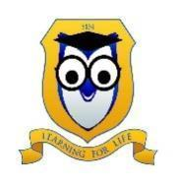
Thomastown Meadows Primary School
Student Dress Code Policy
HONESTY EMPATHY RESPECT
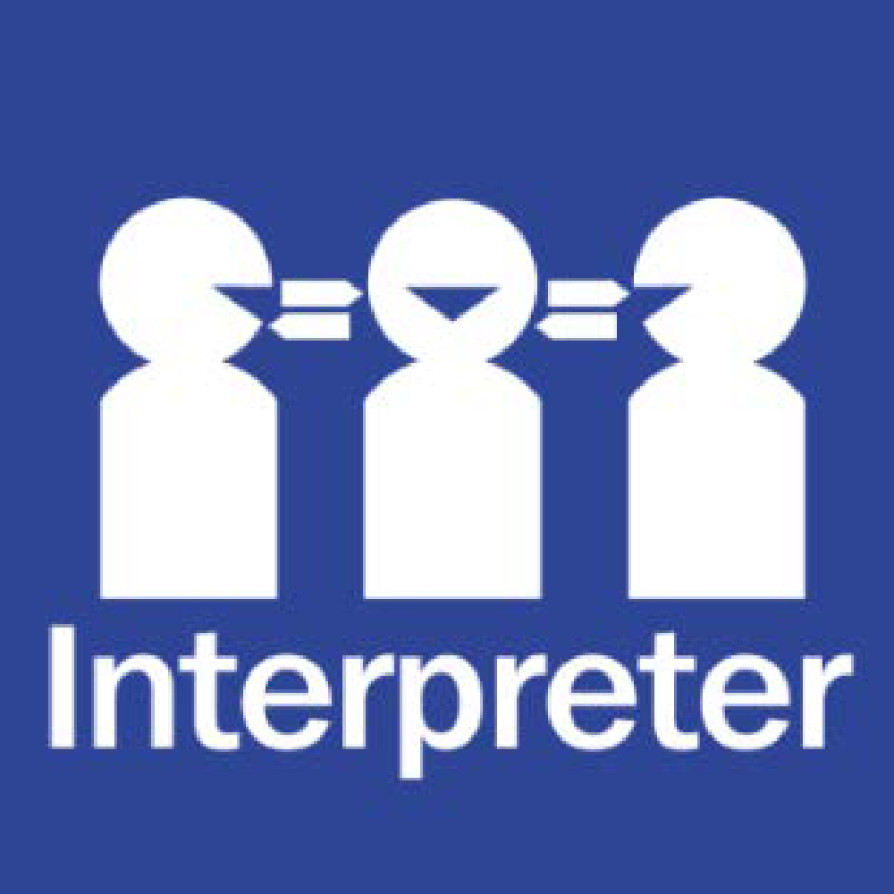
Help for non-English speakers
If you need help to understand the information in this policy please contact Thomastown Meadows Primary School on (03) 9466 1810.

PURPOSE
The purpose of the Student Dress Code is to outline Thomastown Meadows Primary School’s requirements for student dress and appearance and to provide information about uniform purchase and support, dress code implementation and exemption processes.
This dress code has been developed by Thomastown Meadows Primary School’s School Council in close consultation with our school community to ensure that it respects the rights of individual students whilst reflecting the values and interests of our community.

This dress code has been developed in consultation with Thomastown Meadows’ School Council and reviewed in accordance with the Department’s Student Dress Code policy guidance on the Department’s Policy and Advisory Library, available at the following link: https://www2.education.vic.gov.au/pal/student-dress-code/policy

The Student Dress Code aims to:
- foster a sense of community and belonging and encourages students to develop pride in their appearance
- support Thomastown Meadows Primary School’s commitment to ensuring that our students feel equal and are dressed safely and appropriately for school activities
- reduce student competition because of clothing
- enhance the profile and identity of the school and its students within the wider community.

The School Council has developed a dress code that we believe provides a range of choices for students and is cost effective for families.

SCOPE
Students are expected to comply with this Student Dress Code while traveling to and from school, during school hours and when attending school activities.

Uniform and Appearance
The full list of Thomastown Meadows Primary School’s compulsory school uniform items are available at Appendix A to this policy.
General appearance
While at school, travelling to or from school or participating in school activities, Thomastown Meadows Primary School students must comply with the following:
- Summer and winter uniforms are required to be worn appropriately during the corresponding season
- Student Dress Code applies during school hours, while travelling to and from school, and when students are on school excursions
- Uniforms must be clean and in good repair
- Uniforms must be clearly marked with the owner’s name

Jewellery and cosmetics
- Stud earrings worn in the ears, and watches, are permitted.
- For safety reasons and age appropriateness students are limited to one piercing per ear.
- Face, lip, and nose piercings are not permitted.
- Cosmetics and nail polish may not be worn at school. For OHS concerns, nails should not exceed the length of the finger and should not be acrylic or SNS.

Hair and Sun safety
- Shoulder length or longer hair is to be tied back to help restrict the spread of nits and lice, and for student safety.
- Hair bands and ribbons should be royal blue, plain without bedazzlement and safe to wear to school.
- School uniform hats must be worn outside from the beginning of September to the end of April and on any other day prescribed by the school. School uniform hats may also be worn outside of this time, by parent or student choice.
- The only headgear that is acceptable during winter is a royal blue beanie.
- Hats are not to be worn inside.
- Students are permitted to wear sunglasses during outdoor activities. Sunglasses should be close-fitting, wrap-around that meet the Australian Standards 1067 and cover as much of the eye area as possible.

Purchase of Uniforms
Uniform items can be purchased from Academy Uniform.

Support for families experiencing difficulty
Please contact the principal to discuss support that we may be able to provide to families experiencing difficulty meeting uniform costs.
Implementation
Thomastown Meadows Primary School will ensure that this Student Dress Code, including details of uniform items and places of purchase, is communicated to all families and students through our website, and will also be published in the newsletter at the start of each year.

We will assist students who may be experiencing difficulties complying with this policy where possible.

If a student is out of school uniform or otherwise breaches the Student Dress Code on a recurring basis the classroom teacher will issue the student with a notice that will go home to remind the parent. If non-compliance with the dress code becomes a continued occurrence, the principal will be informed, and a phone call home may be required. In this event, the school will continue to work with the student and family to support compliance.
Measures taken by Thomastown Meadows Primary School to address concerns about student non-compliance with the Student Dress Code will also be addressed in accordance with our Student Wellbeing and Engagement Policy.
Exemptions to Student Dress Code
We recognise that there may be situations where the application of this dress code may affect students unequally.
Students and their parents or carers may apply either in writing or in person to the Principal for an exemption to this Student Dress Code if:
- an aspect of this code prevents the student from complying with a requirement of their religious, ethnic, or cultural beliefs or background
- the student has a particular disability or health condition that requires a departure from the dress code

When the Principal receives a request for an exemption, they will:
- consider the grounds for the exemption request
- explain the process to the student and/or their parents/carers
- encourage the student and/or their parents/carers to support their application with evidence.
The principal or delegate will then try to negotiate a resolution that is acceptable to all parties. If an exemption is not allowed, then written reasons will be provided to the student and/or their parents or carers.

Concerns About this Student Dress Code
Thomastown Meadows Primary School welcomes feedback from the school community in relation to this Student Dress Code. If you have a concern or complaint about the Student Dress Code, further information about raising a concern or complaint is available in our school’s Complaints Policy, available on our school website.

Communication
This policy will be communicated to our school community in the following ways:

- Available publicly on our school’s website
- Reminders via Compass posts when required
- Reminders in our school newsletter
- Discussed in student forums
- Included in staff handbook
- Discussed at staff briefings/meetings as required
- Included in transition and enrolment packs
- Discussed at parent information nights
- Hard copy available from school administration upon request
Further Information and Resources
- Thomastown Meadows Primary School SunSmart Policy
- Thomastown Meadows Primary School Parent Complaint Policy
- Thomastown Meadows Primary School Student Wellbeing and Engagement Policy
- Department of Education and Training Student Dress Code
- Department of Education and Training Student Engagement policies and guidelines.

POLICY REVIEW AND APPROVAL

Policy last reviewed | May 2024
Consultation | Sought feedback from School Council (26-04-2022)
Approved by | School Council (26-07-2022)
Next scheduled review date | May 2026
Responsibility | Assistant Principal

APPENDIX A

Winter Uniform Items:
- Royal blue skinny leg track pants - cuffed and knee reinforced
- School jumper
- Royal blue long sleeve polo
- Royal blue windbreaker jacket with removable hood
- Royal blue beanie and scarf with school logo (optional)

Summer Uniform Items:
- Royal blue shorts
- Royal blue skort
- Royal blue short sleeve polo
- School dress – small check design
- Royal blue school legionnaires hat
- House colour polo with logo
Other:
- School Bag
- School Reader Bag
- Library/Excursion drawstring bag

