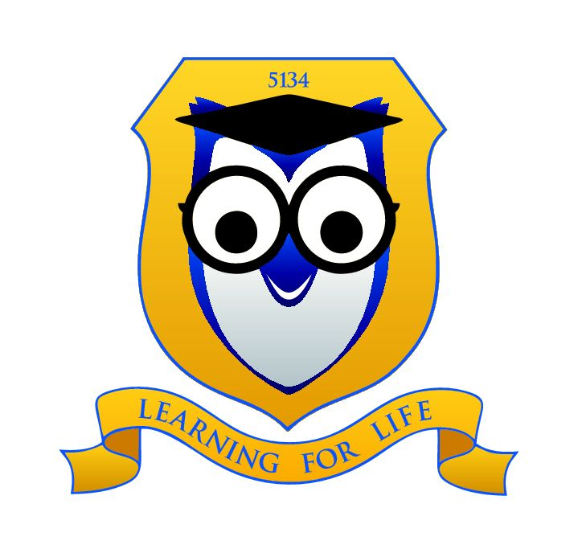 | Thomastown Meadows Primary School
 | Uniform policy
 | HONESTY EMPATHY RESPECT

Purpose
A uniform dress code reinforces in students a pride in their own appearance, instils recognition of themselves as an integral part of the school community, and assists in developing pride in representing their school. Dress codes for cultural or religious beliefs e.g. Hijabs are not restricted as part of this policy. Issues of equality, health and safety, and expense are also factors that contribute to the establishment of the Dress Code. At Thomastown Meadows Primary School it is expected that all student wear school uniform daily.

Scope

- To promote equality amongst all students.
- To further develop a sense of pride in, and identification with our school.
- To provide durable clothing that is cost effective and practical for our school environment.
- To maintain and enhance the positive image of the school in the community.

Policy
After consultation with the school community and the Student Representative Council, School Council has developed a Student Dress Code that we believe provides choice for the students, allows for students to safely engage in the many varied school activities, and caters for the financial constraints of families. It is expected that all students adhere to the guidelines in this policy and the implementation protocols will be reviewed regularly by all staff on yard duty and in classrooms.

- Student Dress Code applies during school hours, while travelling to and from school, and when students are on school excursions.
- Summer and winter uniforms are required to be worn appropriately during the corresponding season. Long sleeve royal blue or white skivvies can be worn under t-shirts for additional warmth.
- School hoodies with a logo are the only hoodies to be worn at school
- Plain royal blue or white leggings can be worn under school approved dresses or skirts but must NOT be worn on their own as pants. Studs and sparkles are not permitted.
- Sunsmart hats that are consistent with our Sunsmart policy must be worn outside from the beginning of September until the end of April. The only headwear that is acceptable during winter is a royal blue beanie. Hats are not to be worn inside.
- Students are permitted to wear navy blue scarves around their neck.
- Students are able to wear wind breakers – vests or jackets, outside in winter but dark colours are preferred e.g. Navy and should be chosen carefully.
- For safety reasons and age appropriateness students are limited to one piercing per ear and must be wearing studs as opposed to sleepers. Face, lip and nose piercings are not permitted.
- Nail polish is not permitted as part of the school uniform. For OHS concerns nails should not exceed the length of the finger.

- Hair bands and ribbons should be royal blue, plain without bedazzlement and safe to wear to school.
- The Student Dress Code, including details of uniform items and places of purchase, will be published in the newsletter at the start of each year.
- Student clothing must be clearly labelled
- This policy will be reviewed as part of the school’s three-year review cycle.
- Students with long hair are encouraged to wear their hair tied up to avoid infestations.
- School Council requires the Principal be responsible for implementation of the Dress Code in a manner consistent with the Student Engagement Policy.
- Arrangements can be made to supply uniforms via State Schools Relief for families experiencing economic hardship.
- Parents seeking exemptions to the Dress Code, for any valid reason must apply in writing to School Council.

Evaluation:

- This policy will be reviewed as part of the school’s three-year review cycle.

This policy was last ratified by School Council October 2016

Policy review

Policy written updated | School Council approved | Review date | Responsibility
October 2016 | October 2016 | October 2019 | Principal

